2.53: a) The change in speed is the area under the a_{x} versus t curve between
vertical lines at 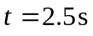 and 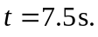 This area is
This acceleration is positive so the change in velocity is positive.

b) Slope of v_{x} versus t is positive and increasing with t.

